**Experiment – 03**

**AIM**: Create a layout for CSE time table in web document using inline styling and/or style tags.

**Basic Tags :**

* HTML**<!DOCTYPE>**Declaration: It is not an HTML tag. It is an instruction to the web browser about what version of HTML the page is written in.
* **<html>** Tag-The HTML document itself begins with <html> and ends with </html>.
* **<head>** Tag-HTML <head> tag is a Container Tag. All Header element contains like general information about page, meta-information, style sheet URL and document type information.
* **<body>** Tag-HTML body section is a main contain section of web page all contain that will be seen when the user loads the webpage.
* **<title>** Tag-The <title> tag is required in all HTML documents and it defines the title of the document.
* **<center>** Tag-It is used to center-align text.
* **<font>** Tag-It specifies the font face, font size, and color of text.
* **<b>** Tag-It specifies bold text.
* **<i>** Tag-Its content is displayed in italic.
* **<u>** Tag-It underlines the text.
* **<span>** Tag-It is used to group inline-elements in a document.
* **<i>** Tag-Its content is displayed in italic.
* **<u>** Tag-It underlines the text.
* **<br>** Tag-It is an empty tag which means that it has no end tag and it inserts a single line break.
* **<table>** Tag-It is a tag element to define a table.
* **<tr>** Tag-It is a tag element to define a table row
* **<td>** Tag-It is a tag element to define a table data
* **<th>** Tag-It is a tag element to define a table heading
* **<caption>** Tag-It is a tag element to define a table caption

**Screenshots:**

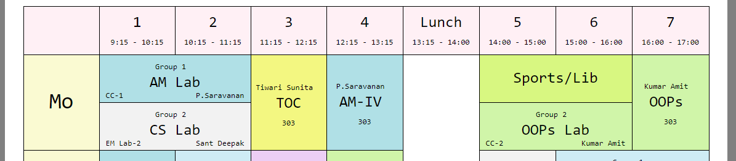

**Fig 3.1: Example of width attribute of table with 95%**

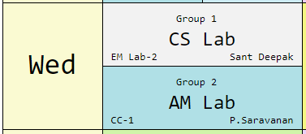 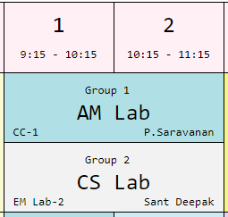

**Fig 3.2: Example of rowspan=2 Fig 3.3: Example of colspan=2**

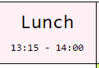 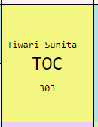

**Fig 3.4: Example of cell padding Fig 3.5: Example of td (table data)**



**Fig 3.6: Example of tr (table row)**

**Attributes of Table**

|  |  |  |
| --- | --- | --- |
| **Attribute** | **Value** | **Description** |
| **width** | Pixels, % | Specifies the width of a table. |
| **colspan** | Number | Allows a single table cell to span the width of more than one cell or column. |
| **rowspan** | Number | Allows a single table cell to span the height of more than one cell or row. |
| **cellpadding** | Pixels | This attribute defines the space between the content of a cell and its border |
| **cellspacing** | Pixels | This attribute defines the size of the space between two cells in a percentage value or pixels. |
| **bgcolor** | rgb(X,X,X)  #XXXXXX  colorname | Specifies the background color for a table. |
| **border** | 1  0 | Specifies whether or not the table is being used for layout purposes |
| **align** | Left  Center  Right | * Left: the table is displayed on the left side of the document. * Center: the table is displayed in the center of the document. * Right: the table is displayed on the right side of the document. |

**Screenshots:**

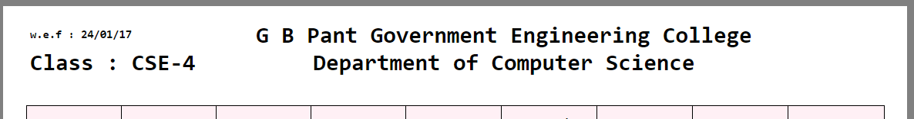

**Fig 3.7: Use of nested div**

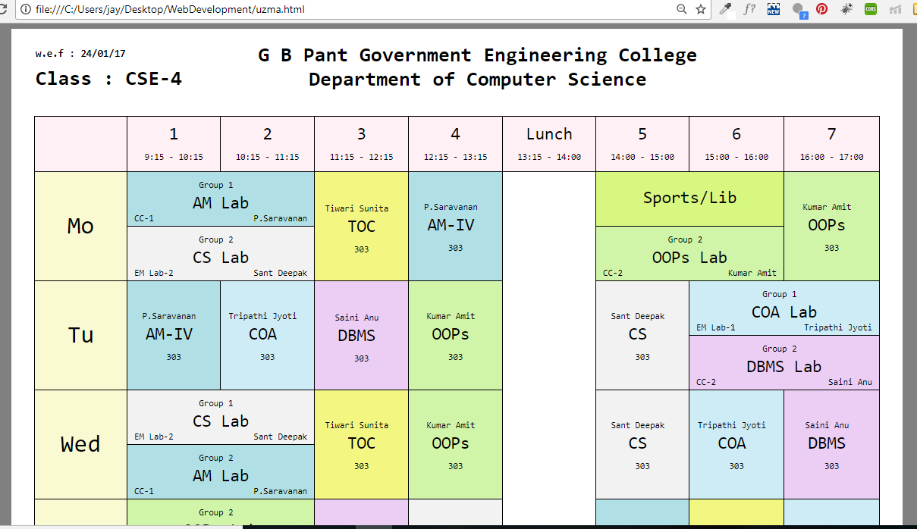

**Fig 3.8: CSE 4 Time Table**

**Code snippets:**

**Code to show the use of nested div :**

<div style="width:88%;height:110%;margin:auto; background-color:white;font-family: monospace;font-size:15px;">

<div>

<div style="width:25%;float:left;margin-left: 35px;">

<p style="margin-top: 28px;font-weight: bold;">w.e.f : 24/01/17<p>

<h1 style="margin-top:-5px;">Class : CSE-4</h1>

</div>

<div style="display:inline-block;">

<center><h1 >G B Pant Government Engineering College<br>

Department of Computer Science</h1></center>

</div>

</div>

**Code for HTML Table with a table cell that spans two rows :**

<td style="border:1px solid black;padding:0px 10px 4px 10px;background-color:#FAFAD2;font-size: 36px;" rowspan="2"><center>Mo</center></td>

**Code for HTML Table with a table cell that spans two columns:**

<table style="border-collapse:collapse;font-size:25px;width: 95%;">

<tr style="background-color:#FFF0F5; ">

<td style="border:1px solid black; padding:10px; width:100px;"><center></center></td>

<td style="border:1px solid black; padding:10px; width:100px;">

<center>1<br><span style="font-size:13px">9:15 - 10:15</span></center></td>

<td style="border:1px solid black; padding:10px; width:100px;">

<center>2<br><span style="font-size:13px">10:15 - 11:15</span></center></td>

<td style="border:1px solid black; padding:10px; width:100px;">

<center>3<br><span style="font-size:13px">11:15 - 12:15</span></center></td>

<td style="border:1px solid black; padding:10px; width:100px;">

<center>4<br><span style="font-size:13px">12:15 - 13:15</span></center></td>

<td style="border:1px solid black; padding:10px; width:100px;" >

<center>Lunch<br><span style="font-size:13px">13:15 - 14:00</span></center></td>

<td style="border:1px solid black; padding:10px; width:100px;">

<center>5<br><span style="font-size:13px">14:00 - 15:00</span></center></td>

<td style="border:1px solid black; padding:10px; width:100px;">

<center>6<br><span style="font-size:13px">15:00 - 16:00</span></center></td>

<td style="border:1px solid black; padding:10px; width:100px;">

<center>7<br><span style="font-size:13px">16:00 - 17:00

</span></center></td>

</tr>

<tr>

<td style="border:1px solid black;padding:0px 10px 4px 10px;background-color:#FAFAD2;font-size: 36px;" rowspan="2"><center>Mo</center></td>

<td style="border:1px solid black; padding:0px 10px 4px 10px;background-color:#B0E0E6;" colspan="2"><center>

<span style="font-size:13px">Group 1</span>

<br>AM Lab<br>

</center>

<span style="font-size:13px;float: left">CC-1</span>

<span style="font-size:13px;float: right;">P.Saravanan</span>

</td>

<td style="border:1px solid black;background-color:#F3F781;" rowspan="2">

<center>

<span style="font-size:13px">Tiwari Sunita</span>

<br>TOC<br>

<span style="font-size:13px">303</span>

</center></td>

<td style="border:1px solid black; padding:0px 10px 4px 10px;background- color:#B0E0E6;" rowspan="2"><center>

<span style="font-size:13px">P.Saravanan</span>

<br>AM-IV

<br>

<span style="font-size:13px">303</span></center></td>

<td style="border:1px solid black; padding:0px 10px 4px 10px;" rowspan="10"><center></center></td>

<td style="border:1px solid black; padding:0px 10px 4px 10px;background-color:#D8F781;" colspan="2"><center>Sports/Lib</center></td>

<td style="border:1px solid black; padding:0px 10px 4px 10px;background-color:#D0F5A9;" rowspan="2"><center>

<span style="font-size:13px">Kumar Amit</span>

<br>OOPs

<br>

<span style="font-size:13px">303</span></center></td>

</tr>

<tr>

<td style="border:1px solid black; padding:0px 10px 4px 10px;background-color:#F2F2F2;" colspan="2"><center>

<span style="font-size:13px">Group 2</span>

<br>CS Lab<br>

</center>

<span style="font-size:13px;float: left">EM Lab-2</span>

<span style="font-size:13px;float: right;">Sant Deepak</span></td>

<td style="border:1px solid black; padding:0px 10px 4px 10px;background-color:#D0F5A9;" colspan="2"><center>

<span style="font-size:13px">Group 2</span>

<br>OOPs Lab<br>

</center>

<span style="font-size:13px;float: left">CC-2</span>

<span style="font-size:13px;float: right;">Kumar Amit</span></td>

</tr>

<tr>

<td style="border:1px solid black; padding:0px 10px 4px 10px;background-color:#FAFAD2;font-size: 36px;" rowspan="2"><center>Tu</center></td>

<td style="border:1px solid black; padding:0px 10px 4px 10px;background-color:#B0E0E6;" rowspan="2"><center>

<span style="font-size:13px">P.Saravanan</span>

<br>AM-IV

<br>

<span style="font-size:13px">303</span></center></td>

<td style="border:1px solid black; padding:0px 10px 4px 10px;background-color:#CEECF5;" rowspan="2"><center>

<span style="font-size:13px">Tripathi Jyoti</span>

<br>COA

<br>

<span style="font-size:13px">303</span></center></td>

<td style="border:1px solid black; padding:10px;background-color:#ECCEF5;" rowspan="2"><center>

<span style="font-size:13px">Saini Anu</span>

<br>DBMS

<br>

<span style="font-size:13px">303</span></center></td>

<td style="border:1px solid black; padding:0px 10px 4px 10px;background-color:#D0F5A9;" rowspan="2"><center>

<span style="font-size:13px">Kumar Amit</span>

<br>OOPs

<br>

<span style="font-size:13px">303</span></center></td>

<td style="border:1px solid black;padding:0px 10px 4px 10px;background-color:#F2F2F2;" rowspan="2"><center>

<span style="font-size:13px">Sant Deepak</span>

<br>CS

<br>

<span style="font-size:13px">303</span></center></td>

<td style="border:1px solid black; padding:0px 10px 4px 10px;background-color:#CEECF5;" colspan="2"><center>

<span style="font-size:13px">Group 1</span>

<br>COA Lab<br>

</center>

<span style="font-size:13px;float: left">EM Lab-1</span>

<span style="font-size:13px;float: right;">Tripathi Jyoti</span></td>

<tr>

<td style="border:1px solid black; padding:0px 10px 4px 10px;background-color:#ECCEF5;" colspan="2"><center>

<span style="font-size:13px">Group 2</span>

<br>DBMS Lab<br>

</center>

<span style="font-size:13px;float: left">CC-2</span>

<span style="font-size:13px;float: right;">Saini Anu</span></td>

</tr>

<tr style="font-size:25px; ">

<td style="border:1px solid black; padding:0px 10px 4px 10px;background-color:#FAFAD2;font-size: 36px;" rowspan="2"><center>Wed</center></td>

<td style="border:1px solid black; padding:0px 10px 4px 10px;background-color:#F2F2F2;" colspan="2"><center>

<span style="font-size:13px">Group 1</span>

<br>CS Lab<br>

</center>

<span style="font-size:13px;float: left">EM Lab-2</span>

<span style="font-size:13px;float: right;">Sant Deepak</span></td>

<td style="border:1px solid black; padding:0px 10px 4px 10px;background-color:#F3F781;" rowspan="2"><center>

<span style="font-size:13px">Tiwari Sunita</span>

<br>TOC<br>

<span style="font-size:13px">303</span>

</center></td>

<td style="border:1px solid black;padding:0px 10px 4px 10px;background-color:#D0F5A9;" rowspan="2"><center>

<span style="font-size:13px">Kumar Amit</span>

<br>OOPs

<br>

<span style="font-size:13px">303</span></center></td>

<td style="border:1px solid black;padding:0px 10px 4px 10px;background-color:#F2F2F2;" rowspan="2"><center>

<span style="font-size:13px">Sant Deepak</span>

<br>CS

<br>

<span style="font-size:13px">303</span></center></td>

<td style="border:1px solid black; padding:0px 10px 4px 10px;background-color:#CEECF5;" rowspan="2"><center>

<span style="font-size:13px">Tripathi Jyoti</span>

<br>COA

<br>

<span style="font-size:13px">303</span></center></td>

<td style="border:1px solid black; padding:0px 10px 4px 10px;background-color:#ECCEF5;" rowspan="2"><center>

<span style="font-size:13px">Saini Anu</span>

<br>DBMS

<br>

<span style="font-size:13px">303</span></center></td>

</tr>

<tr>

<td style="border:1px solid black; padding:0px 10px 4px 10px;background-color:#B0E0E6;" colspan="2"><center>

<span style="font-size:13px">Group 2</span>

<br>AM Lab<br>

</center>

<span style="font-size:13px;float: left">CC-1</span>

<span style="font-size:13px;float: right;">P.Saravanan</span></td>

</tr>